Given the root of a binary tree, find the largest subtree, which is also a Binary Search Tree (BST), where the largest means subtree has the largest number of nodes.

A **Binary Search Tree (BST)** is a tree in which all the nodes follow the below-mentioned properties:

* The left subtree values are less than the value of their parent (root) node's value.
* The right subtree values are greater than the value of their parent (root) node's value.

**Note:** A subtree must include all of its descendants.

**Follow up:** Can you figure out ways to solve it with O(n) time complexity?

**Example 1:**

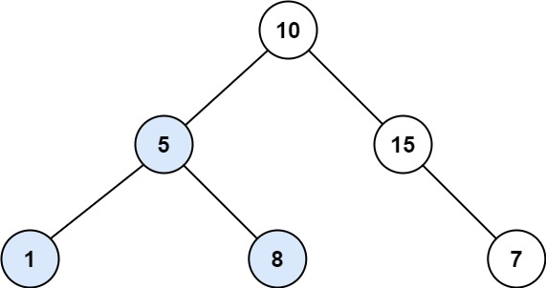

**Input:** root = [10,5,15,1,8,null,7]

**Output:** 3

**Explanation:** The Largest BST Subtree in this case is the highlighted one. The return value is the subtree's size, which is 3.

**Example 2:**

**Input:** root = [4,2,7,2,3,5,null,2,null,null,null,null,null,1]

**Output:** 2

**Constraints:**

* The number of nodes in the tree is in the range [0, 104].
* -104 <= Node.val <= 104